

Welcome to UA-CALT!!
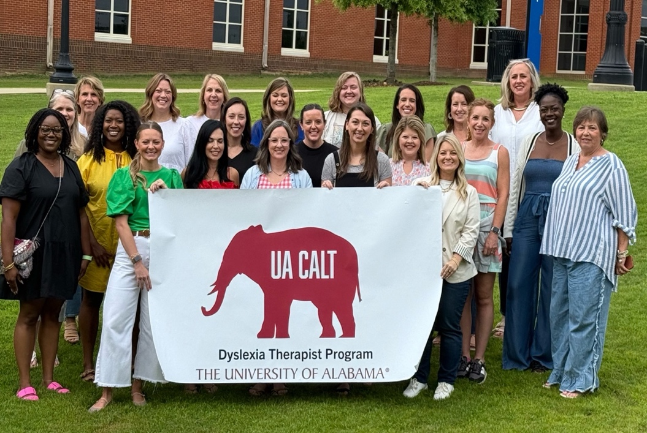
The June class will begin at 10:00 on Monday, June 2. We will be meeting in Room 1016 in the Tom Barnes Education Building at 260 Kilgore Lane.
Directions: https://inservice.ua.edu/center/directions/

Housing
After class we will take you to Highlands Apartments, where the CALT program is providing housing for you through Thursday night.

General information about Highlands Apartments
https://housing.sl.ua.edu/halls/highlands/

You must bring your own bedding for a twin bed,
towels and toiletries.

Contact Dr. Diane Sekeres with questions:
dcsekere@ua.edu

